NYSFBC ‘States’ Agenda 2018
Saturday 10/27
10:30am-12pm Rehearsal
11-12 Lunch on your own
1-4:00 Last rehearsal block of the 2018 season
4:15 Family and Friends Final Performance
4:15- 5:00 Change into costumes
5:15-7 Dinner/Snack/Costume Party in Houghton Park or the Café, Band Club provides Pizza, food donations requested
Students will vote for the following Costume Categories.
- Scariest
- Most Realistic
- Most Creative
- Most Bandfull
- Most Elegant
- Worst Costume

Sunday 10/30
8am-9:30 Rehearse at CPPHS
9:40 Load the truck!!
10:15 Depart for warm up, 621 Skytop Rd, Syracuse, NY 13210
12:45pm Arrive, unload, (Show 2 Starts @ 1pm)
1:15-2:00 Warm Up
2:05-2:25 Full Ensemble Rehearsal
2:40 Load the truck and busses
3:08 Depart for the Carrier Dome, 900 Irving Ave, Syracuse, NY 13244
3:23 Arrive, unload, stage.
4:08 GAME TIME. After the performance, we need chaperones helping push the pit equipment out of the stadium while pictures are being taken.
After loading, students and chaperones will head to sit in Section G117, this is on Side 2, between the 35 and 25, in the back section. We will be between Jamestown and Kingston, and behind Orchard Park.
5:15 Line up for retreat. We will be lined up Side 1 35 and 40 between West Seneca and Rome
After retreat we will celebrate, meet near the busses and leave. If you are taking a student home, you need to come check them out with a Chaperone physically.
In Cortland – We will stop for about 30 minutes to allow students to grab a snack.
9pm Estimated arrival time back at CPPHS
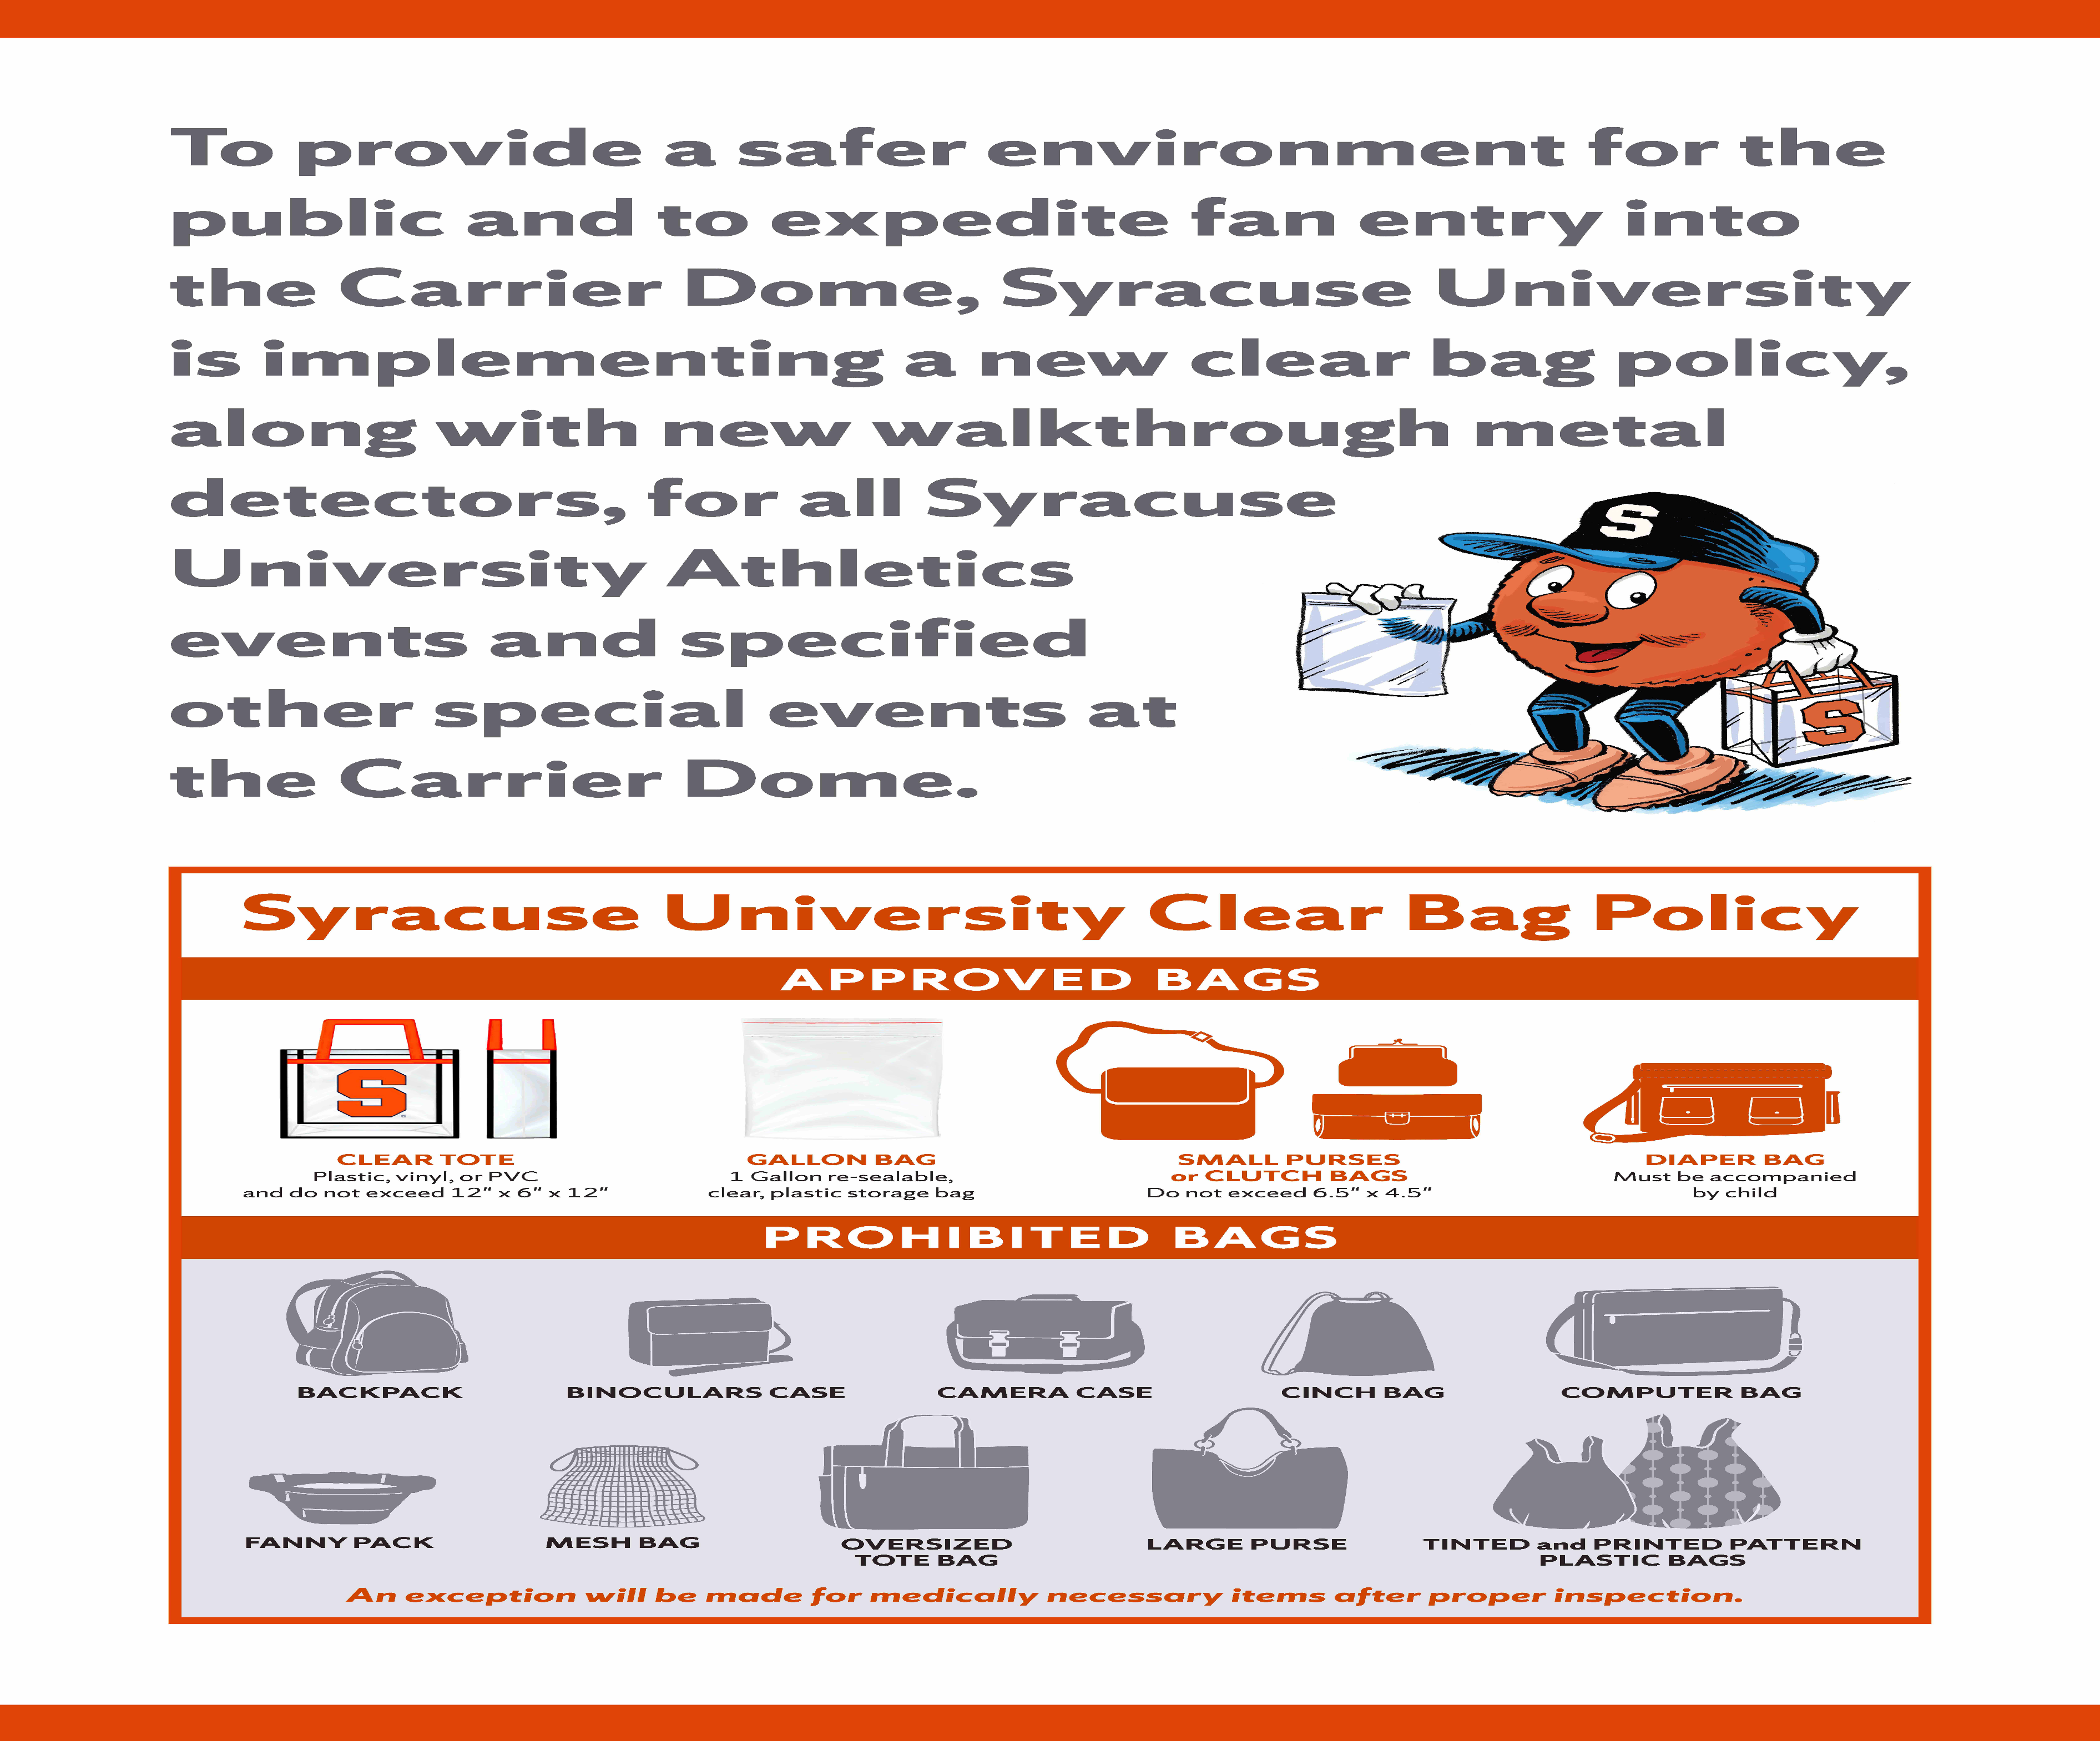
SPECTATOR TICKETS: may be purchased on day of Championship at ticket booths outside GATE’s A, B and C at the Dome or at the main ticket window inside GATE B. GATE’s A, B, C, F, G and H will be open for entrance. * Adult Price is - $19.00 * Senior Citizen – 65 and older - $134.00 * Student’s (Public School Age) 18 years and under - $13.00 * No reserve seating, group rates or pre-sale tickets are available for championship.

PARKING ON CAMPUS: There is plenty of parking near the dome for spectators. The cost for parking is $10.00. Down $5.00 from last year

HANDICAP PARKING: Handicap parking is located near the Archibold gym. See an SU parking attendant for assistance.

SOUVENIR PROGRAMS: Official souvenir programs will be available for $6.00. These full color programs are the official yearbook of the conference.

COMPETITION RESULTS: www.NYSFBC.org Check periodically for Conference information. Championship Show scores will be posted on this site as each retreat is completed.

NEW CARRIER DOME ENTRANCE POLICY: Please review new entrance policy for the
Carrier Dome.
Spectators will be able to carry one of the following style and size bag at stadium gates:
• Bags that are clear plastic, vinyl or PVC and do not exceed 12” x 6” x 12”
— OR —
• One-gallon clear plastic freezer bag (Ziploc bag or similar).
Please see diagram above

STAFF BACKPACKS: ANY BACKPACK OR LARGE BAG NEEDED FOR YOUR PERFORMANCE MUST ENTER THRU THE AIRLOCK. Only Field pass or Video pass holders will be allowed to bring in backpacks or bags. PLEASE, these must be kept to a minimum. If they are absolutely necessary they must come thru the airlock and will be searched by Carrier Dome Security. This includes your video person and any chaperones bag that it is necessary. A staff member may have to bring in a Chaperones bag. ONLY FIELD PASSES AND VIDEO PASSES WILL BE ALLOWED. Please bring with you only what is needed for the performance of the band.

