2018 CPPHS Bands Wreath Sale
22" - 24" (12" ring) Single-Sided Balsam & Fraser Fir Wreaths $20 each Wreath will have a RED Bow
Provided by Syracuse Christmas Tree Farm. Available After Thanksgiving
MAKE CHECKS PAYABLE TO: CPPHS BANDS
 | Name | Address | Phone Number | Number of Wreaths | Total | Paid

Student Name: ______________________________________________ Phone #:____________________________________
TURN IN DATE: October 23rd 5:00pm – 8:00pm Cafeteria/ Lobby or place in Black Lock Box (before 4pm)
 | Name | Address | Phone Number | Number of Wreaths | Total | Paid
13.
Student Name: ______________________________________________ Phone #:____________________________________
TURN IN DATE: October 23rd 5:00pm – 8:00pm Cafeteria/ Lobby or place in Black Lock Box (before 4pm)
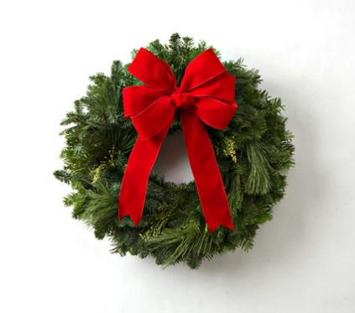

CPPHS Bands Wreath Sale
Start Date: October 11th
End Date: October 23rd

The band will be selling wreaths for $20 each.
The student profit = $8.00 for each wreath sold.
If you have questions please contact:
Erika Lakota: elakota1@gmail.com or 542-5598
Make Checks Payable to: CPPHS Bands

TURN IN DATE: October 23rd 5:00pm – 8:00pm Cafeteria/ Lobby or place in Black Lock Box (before 4pm)
(Please keep Vitrix and wreath orders/money separate)
Wreaths will be delivered after Thanksgiving

