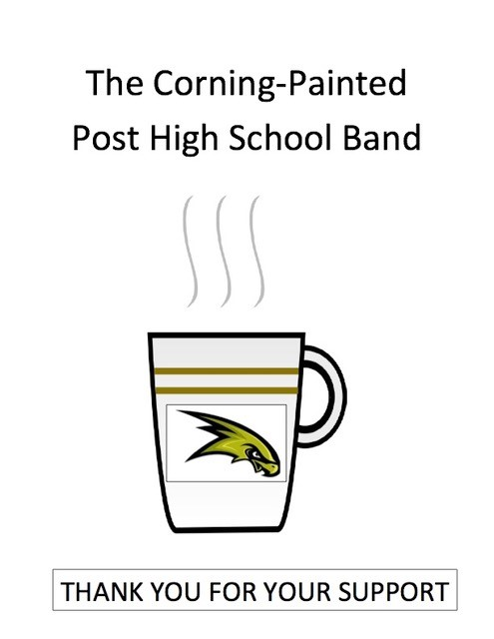  Corning-PP High School Band |  | Heavenly Cup Coffee Roasters llc 323 S. Hamilon St Painted Post, NY 14870 www.heavenlycup.com | 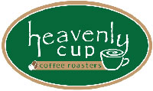
 |  | 100% Fresh Roasted Arabica Specialty Coffees
Coffee Name: | Origin: | Roast: | Description ( 10 oz Bag) |  |  | Size:
Decaf Brazil | Central America | Vienna (medium dark) | Decaffeinated by Water Process |  |  | 10oz Bag
Breakfast Blend | Blended | Full City (medium) | Northeast favorite, bright and clean |  |  | 10oz Bag
Sumatra | Indonesian | Vienna (medium dark) | Complex, floral and earthy |  |  | 10oz Bag
Guatemala French Roast | Antigua Valley | French (dark) Roast | Dark, spicy, earthy, dark chocolate, and has a mild wine aftertaste. |  |  | 10oz Bag
Colombia | Central America | French (dark) | Sweet, rich, carmelized, full bodied |  |  | 10oz Bag
 |  |  |  |  |  | 10oz Bag
 |  | Flavored Arabica Coffees
Coffee Name: | Description: (10 oz Bag)
 |  |  |  |  |  | Size:
Pumpkin Spice | Reminiscent of pumpkin pie with holiday spices |  | 10oz Bag
French Vanilla | Creamy smooth french vanilla and a tiny dash of Caramel |  | 10oz Bag
Rainforest Caramel Crunch | Sweet, smooth and buttery tropical nut mixture, dipped in a pool of rich, sticky caramel. - 10oz bag |  |  |  |  | 10oz Bag
Tea Varieties: | Description: (2.5 oz Bag)
 |  |  |  |  |  | Size:
Ceylon Green | A green tea from Sri Lanka, formerly Ceylon (may be infused several times) | 2.5 oz Bag
English Breakfast | A smooth sipping blend of single estate black teas |  |  |  |  |  | 2.5 oz Bag
Creamsicle | Vanilla & orange Rooibos, naturally caffeine free, high in anti-oxidants, serve hot or cold |  |  | 2.5 oz Bag
Orange Detox | Blend of alfalfa, nettle, dandelion, red clover, plantain, peppermint. Cleanses the body of toxins, caffeine free |  |  |  |  | 2.5 oz Bag
 |  |  |  |  |  | 2.5 oz Bag
Single Serve Cups: | Description: (10 cups/Bag)
Same flavor as above | Same flavor as above coffee |  |  | 10 cups/Bag |  | Size:

